**PROJECT PROFILE**

|  |  |
| --- | --- |
| Project Name | Online Hotel Room Booking |
| Platform | Windows 10 |
| Front End | PHP |
| Back End | MySQL |
| Documentation Tool | MS Word |
| Web Server | Apache (XAMPP) |
| Web Browser | Google Chrome, Microsoft Edge |
| Editor | Visual Studio Code |
| Project ID | BCA24_012 |
| Guided By | Miss Radhika Raghani |
| Submitted To | Smt. K.S.N. Kansagra Mahila College |
| Project Duration | 3 Months |

**PROJECT DEFINITION**

* **Reason for choosing this definition**

An online hotel room booking system allows guests to book rooms. An efficient booking system simplifies the process, making it convenient for travelers.

* **Purpose**

A hotel room booking website lets guests book rooms quickly online. It’s like a digital “Reserved” sign.

* **General Information**

A hotel room booking is like a hotel’s digital reception desk. Our website is about its location, what rooms look like, and other services.

It reduces manual work and improves the efficiency:

1. To store records
2. Control Booking and services
3. Billing

## ANALYSIS

1. **Admin Side Analysis**

* **Admin login –** only the admin can login to this page.
* **User Profile –** The admin can view the user profile.
* **Review –** The admin can view and delete the review.
* **Receive Message –** TheAdmin can view and delete the user's message which is sent by email.
* **Manage Room -**The Admin can view, insert, update and delete the rooms.
* **Manage Booking -**The Admin can view and delete the booking.
* **Log out –** Through this page, the admin can log out of his/her account.

1. **User Side Analysis**

* **Login/Register –** The user can login and register to view the site.
* **Search Room –** The user can search the room and view the results.
* **Reserve Room–** The user can book and cancel the room.
* **Services –** Users can view the services like transportation, food, bar & drink etc and take the facilities with rooms.
* **Review –** The user can send a review about the Room and website.
* **About us –** Users can view the events, Activities, and about the website.
* **Contact us –** Users can contact us by email or contact number.
* **Log out –** The user can log out from his/her account through the page.

## FEASIBILITY STUDY

Feasibility when starting a Project you would need to look at if it is possible to create this project.

A feasibility study analyses the viability of a project to determine whether the project or venture is likely to succeed.

The study is also designed to identify potential issues and problems that could arise while pursing the project.

This system aims to determine quickly and at a minimum expense to establish how to solve a problem.

1. **Technical Feasibility**

**Hardware Requirement**

|  |  |
| --- | --- |
| RAM | Minimum 1 GB |
| Hard Disk | 250 GB |
| Processor | I5 |

**Software Requirement**

|  |  |
| --- | --- |
| Operating System | Windows 10 |
| Front End | PHP |
| Back End | MySQL |
| Web Server | Apache (XAMPP) |
| Web Browser | Chrome, Microsoft Edge |

1. **Operational Feasibility**

* Operational feasibility criteria measure the urgency of the problem or the acceptability of a solution.
* Work properly if it is being developed and implemented.
* Easy to maintain.

1. **Economic Feasibility**

* All the necessary hardware and software are available in the market at a low cost.
* Our template is free.
* Does not need any cost in the future.
* Hardware and software are also free.
* Hence it is economically feasible.

1. **Time Feasibility**

* Time feasibility consists of how much time you take to complete your project.
* Our project will be completed in around 3 months.
* Hence it is timely and feasible.

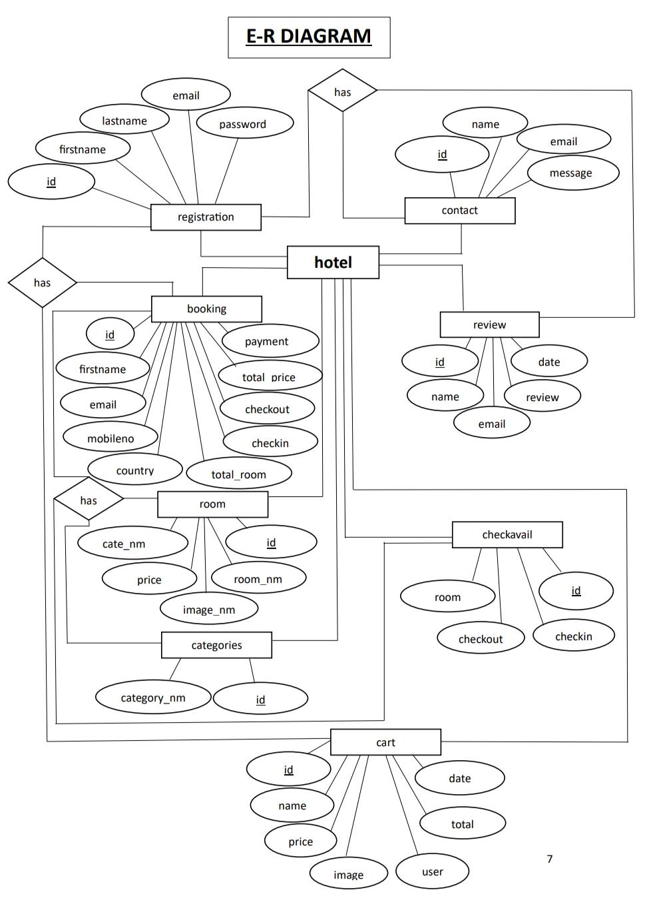

**DFD Notations**

**EXTERNAL ENTITY (TERMINATOR):-**

* It represented external entities with which system communicate.
* A terminator can be a person or a group of people.
* They are outside the control of the system that is being model.
* It may also be another system.

**DATA STORE:-**

* It is used to model a collection of data packets at rest.

**PROCESS (PRESENTATION):-**

* A process is represented graphically as a circle Rectangle with rounded edge.

**DATA FLOW:-**

* It is used to describe the more event of data or physical material from one part of the system to another part

**DATA FLOW DIAGRAM**

Request

###### User

Request

###### Admin

Response

Response

**Level 0 : DFD for User Side**

|  |
| --- |
| 1. |
| Login |

|  |  |
| --- | --- |
| T1 | registration |

|  |
| --- |
| 2. |
| Registration |

|  |  |
| --- | --- |
| T1 | registration |

|  |
| --- |
| 3. |
| View Room |

|  |  |
| --- | --- |
| T2 | room |

###### User

|  |
| --- |
| 4. |
| About Us |

|  |
| --- |
| 5. |
| View  Services |

|  |
| --- |
| 6. |
| View  Testimonials |

**Level 1 : DFD for User Side**

|  |
| --- |
| 1. |
| view room |

|  |  |
| --- | --- |
| T2 | room |

|  |
| --- |
| 1. |
| view room |

|  |
| --- |
| 1. |
| view room |

|  |
| --- |
| 2. |
| reserve room |

|  |
| --- |
| 1. |
| view room |

|  |  |
| --- | --- |
| T3 | cart |

|  |
| --- |
| 1. |
| view room |

|  |
| --- |
| 1. |
| view room |

|  |
| --- |
| 3. |
| Book room |

|  |
| --- |
| 1. |
| view room |

|  |  |
| --- | --- |
| T4 | booking |

|  |
| --- |
| 1. |
| view room |

|  |
| --- |
| 4. |
| Add to cart |

|  |  |
| --- | --- |
| T3 | cart |

|  |
| --- |
| 1. |
| view room |

|  |
| --- |
| 1. |
| view room |

|  |
| --- |
| 5. |
| Manage cart |

|  |
| --- |
| 1. |
| view room |

|  |  |
| --- | --- |
| T3 | cart |

**user**

**User login**

|  |
| --- |
| 1. |
| view room |

|  |
| --- |
| 1. |
| view room |

|  |
| --- |
| 6. |
| Manage booking |

|  |
| --- |
| 1. |
| view room |

|  |  |
| --- | --- |
| T4 | booking |

|  |
| --- |
| 1. |
| view room |

|  |
| --- |
| 7. |
| contact |

|  |
| --- |
| 1. |
| view room |

|  |  |
| --- | --- |
| T6 | contact |

|  |
| --- |
| 1. |
| view room |

|  |
| --- |
| 1. |
| view room |

|  |
| --- |
| 8. |
| Give review |

|  |  |
| --- | --- |
| T5 | review |

|  |
| --- |
| 1. |
| view room |

|  |
| --- |
| 1. |
| view room |

|  |
| --- |
| 9. |
| logout |

|  |
| --- |
| 1. |
| view room |

|  |
| --- |
| 1. |
| view room |

|  |
| --- |
| 1. |
| view room |

|  |
| --- |
| 1. |
| view room |

**Level 2 : DFD for User Side**

|  |
| --- |
| 3. |
| Update cart |

|  |
| --- |
| 4. |
| Delete cart |

|  |
| --- |
| 1. |
| Add to cart |

|  |
| --- |
| 2. |
| view cart |

|  |  |
| --- | --- |
| T3 | cart |

Manage cart

###### User

|  |  |
| --- | --- |
| T4 | booking |

**Level 2 : DFD for User Side**

|  |
| --- |
| 1. |
| View booking |

|  |
| --- |
| 2. |
| Cancel booking |

###### User

Manage booking

**Level 0 : DFD for Admin Side**

|  |
| --- |
| 1. |
| View user |

|  |
| --- |
| 2. |
| Manage room |

|  |
| --- |
| 3. |
| Manage  category |

|  |
| --- |
| 4. |
| Manage booking |

|  |
| --- |
| 5. |
| View booked room |

|  |
| --- |
| 6. |
| View Review |

|  |
| --- |
| 7. |
| View message |

|  |
| --- |
| 8. |
| logout |

|  |  |
| --- | --- |
| T1 | registration |

|  |  |
| --- | --- |
| T5 | review |

|  |  |
| --- | --- |
| T6 | contact |

|  |  |
| --- | --- |
| T3 | cart |

|  |  |
| --- | --- |
| T7 | categories |

|  |  |
| --- | --- |
| T4 | booking |

|  |  |
| --- | --- |
| T2 | room |

**Admin**

**Level 1 : DFD for Admin Side**

|  |
| --- |
| 1. |
| View |

|  |
| --- |
| 2. |
| logout |

|  |  |
| --- | --- |
| T1 | registration |

###### Admin

|  |  |
| --- | --- |
| T6 | contact |

View user

**Level 1 : DFD for Admin Side**

|  |
| --- |
| 1. |
| Add room |

|  |
| --- |
| 2. |
| Update room |

|  |  |
| --- | --- |
| T2 | room |

###### Admin

|  |  |
| --- | --- |
| T6 | contact |

Manage room

|  |
| --- |
| 3. |
| Delete room |

**Level 1 : DFD for Admin Side**

|  |
| --- |
| 1. |
| Insert |

|  |
| --- |
| 1. |
| Add room |

|  |
| --- |
| 2. |
| Update room |

|  |
| --- |
| 1. |
| Add room |

|  |  |
| --- | --- |
| T7 | categories |

|  |
| --- |
| 2. |
| Update |

###### Admin

|  |  |
| --- | --- |
| T6 | contact |

Manage category

|  |
| --- |
| 3. |
| Delete |

|  |
| --- |
| 3. |
| Delete room |

**Level 1 : DFD for Admin Side**

|  |
| --- |
| 1. |
| view |

###### Admin

|  |  |
| --- | --- |
| T6 | contact |

Manage booking

|  |  |
| --- | --- |
| T4 | booking |

|  |
| --- |
| 2. |
| delete |

**Level 1 : DFD for Admin Side**

|  |
| --- |
| 1. |
| view |

###### Admin

|  |  |
| --- | --- |
| T6 | contact |

|  |  |
| --- | --- |
| T3 | cart |

Booked room

|  |
| --- |
| 2. |
| logout |

**Level 1 : DFD for Admin Side**

|  |
| --- |
| 1. |
| view |

###### Admin

|  |  |
| --- | --- |
| T6 | contact |

View review

|  |  |
| --- | --- |
| T5 | review |

|  |
| --- |
| 2. |
| delete |

**Level 1 : DFD for Admin Side**

|  |
| --- |
| 1. |
| view |

###### Admin

|  |  |
| --- | --- |
| T6 | contact |

View message

|  |  |
| --- | --- |
| T6 | contact |

|  |
| --- |
| 2. |
| delete |

**USECASE**

**USER**

login

View User

View Bookedroom

**ADMIN**

manage room

add room

delete room

update room

View Booking

add category

delete category

edit category

View review

logout

View contact

**DATA DICTIONARY**

**DATABASE NAME:- hotel**

**TABLE NAME:- registration**

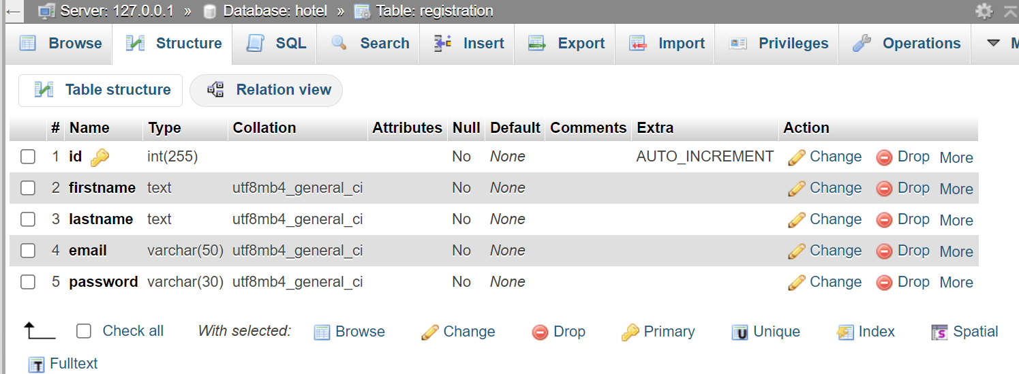

**DESCRIPTION:-** Details of all users are been stored in this table.

**TABLE NAME:- room**

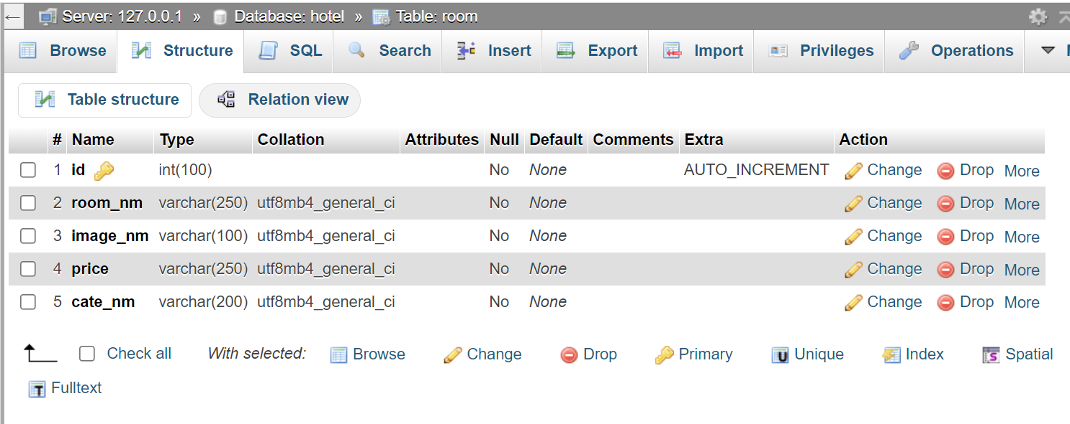

**DESCRIPTION:-** Rooms with details are been stored in this table.

**TABLE NAME:- categories**

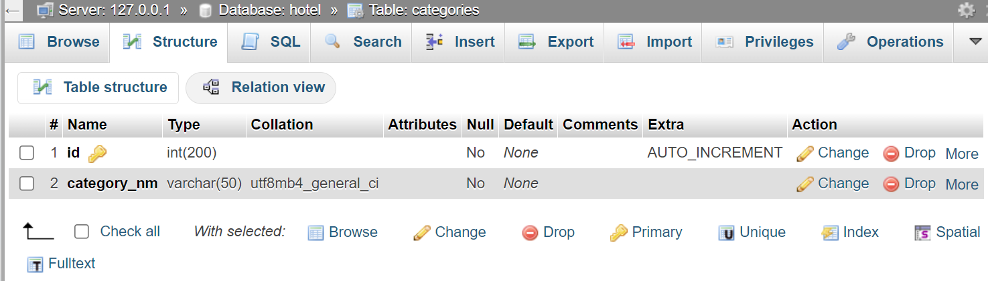

**DESCRIPTION:-** Categories of the rooms with the details are been stored in this table.

**TABLE NAME:- booking**

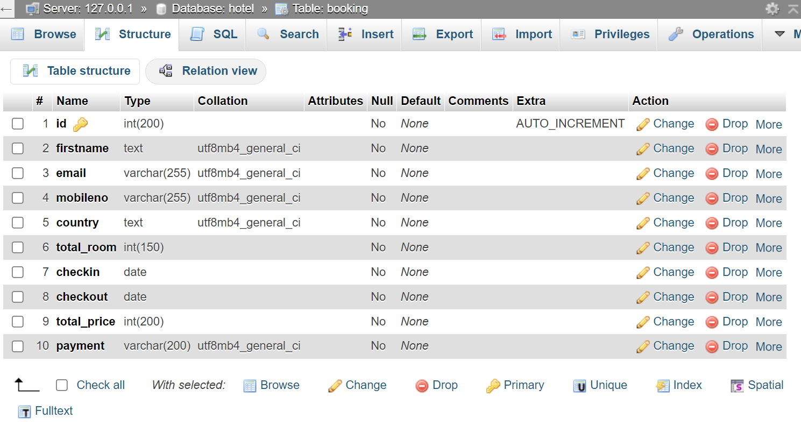

**DESCRIPTION:-** Reservations made by Users are been stored in this table.

**TABLE NAME:- cart**

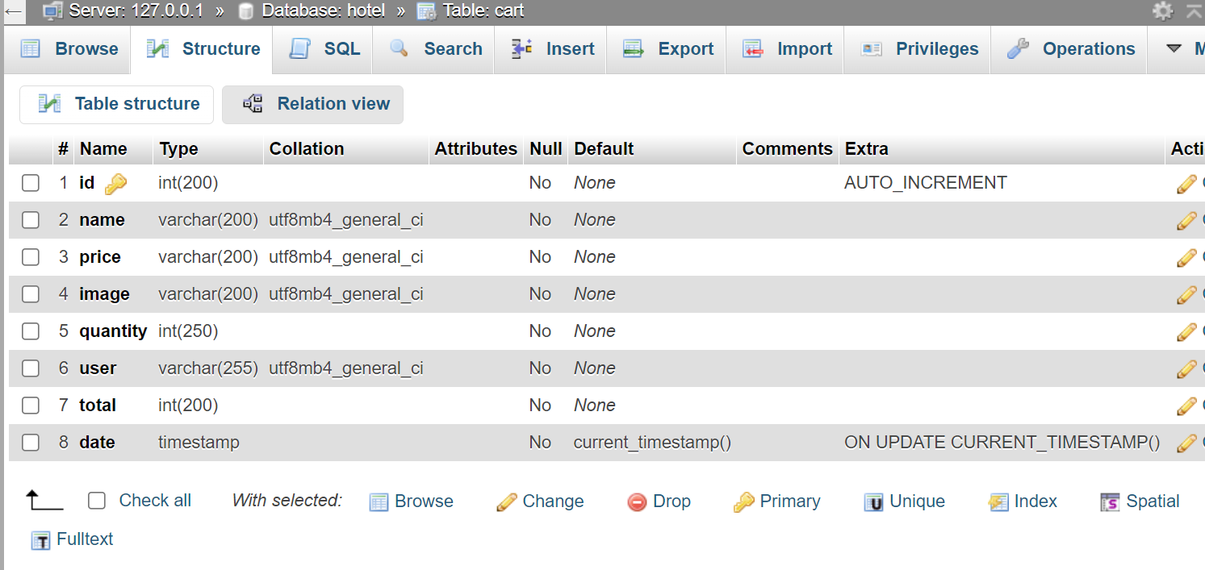

**DESCRIPTION:-** User’s room booked details are been stored in this table.

**TABLE NAME:- contact**

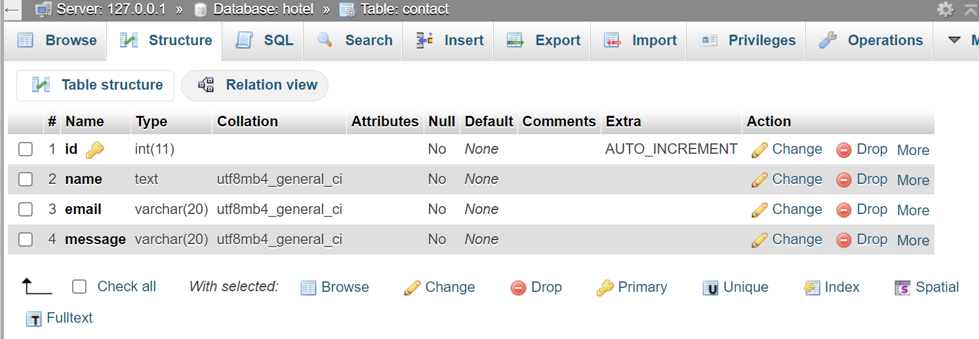

**DESCRIPTION:-** Users’ queries are been stored in this table.

**TABLE NAME:- review**

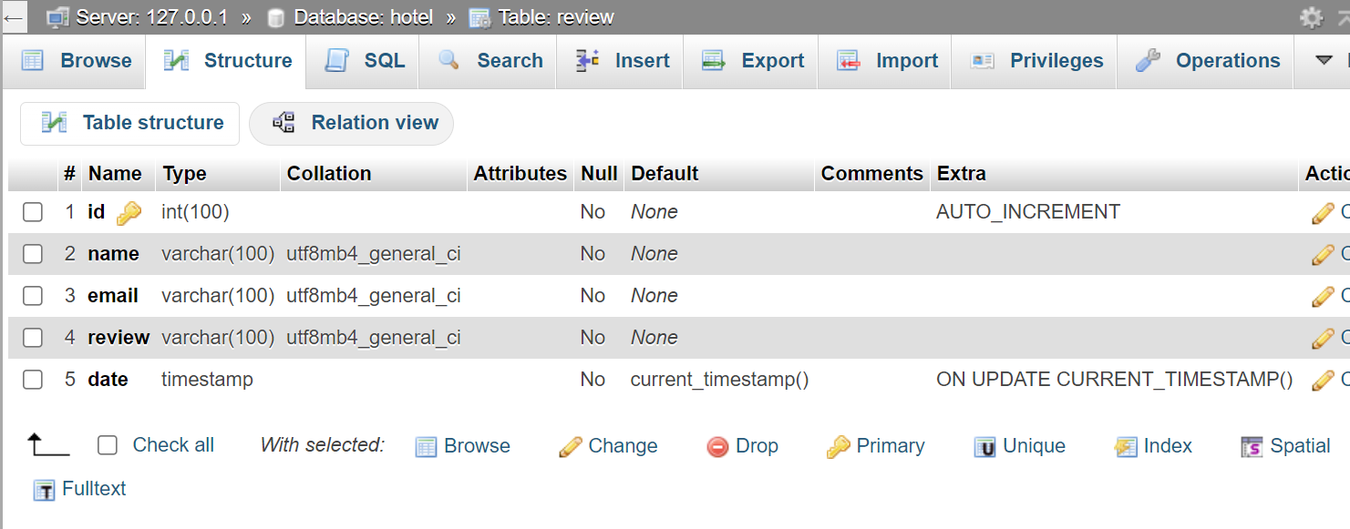

**DESCRIPTION:-** Users reviews and messages are been stored in this table.

**TABLE NAME:- checkavail**

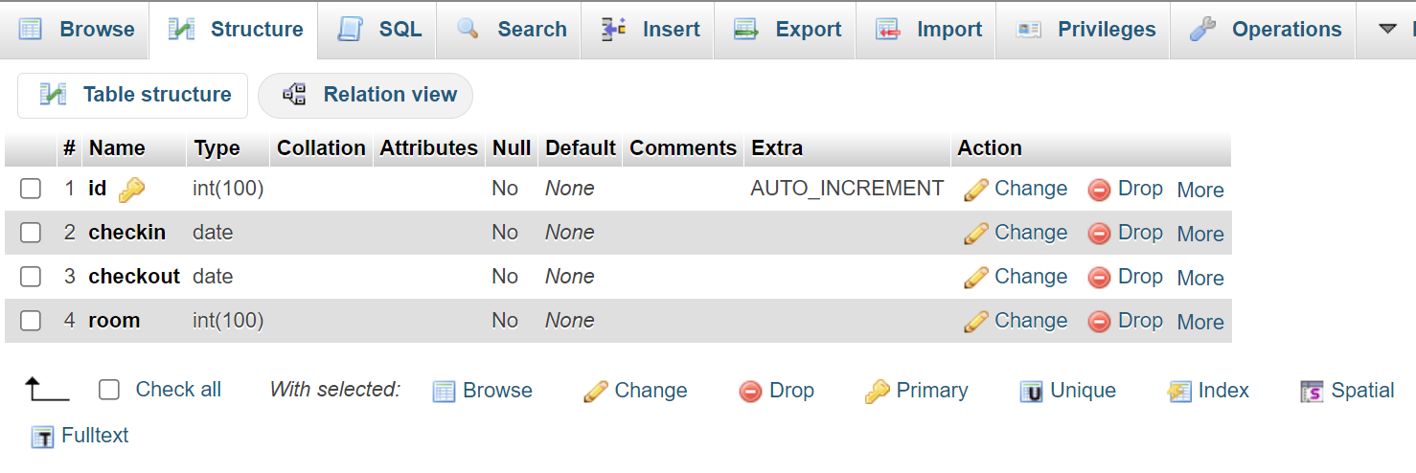

**DESCRIPTION:-** User’s check available rooms date are been stored in this table.

**SCREEN LAYOUT**

**User Side**

**1.HOME PAGE:**

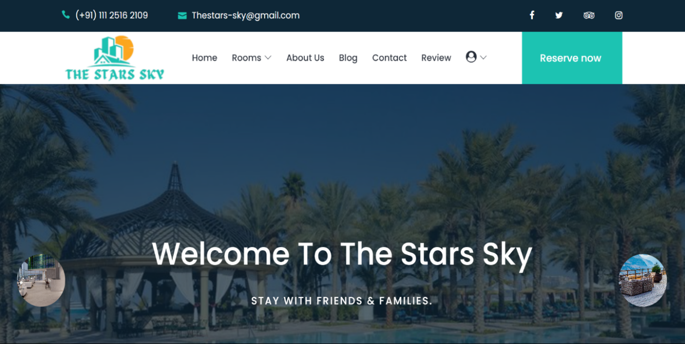

**DESCRIPTION:-** When Users visit this site before login, this page

is viewed.

**2.HOME PAGE:**

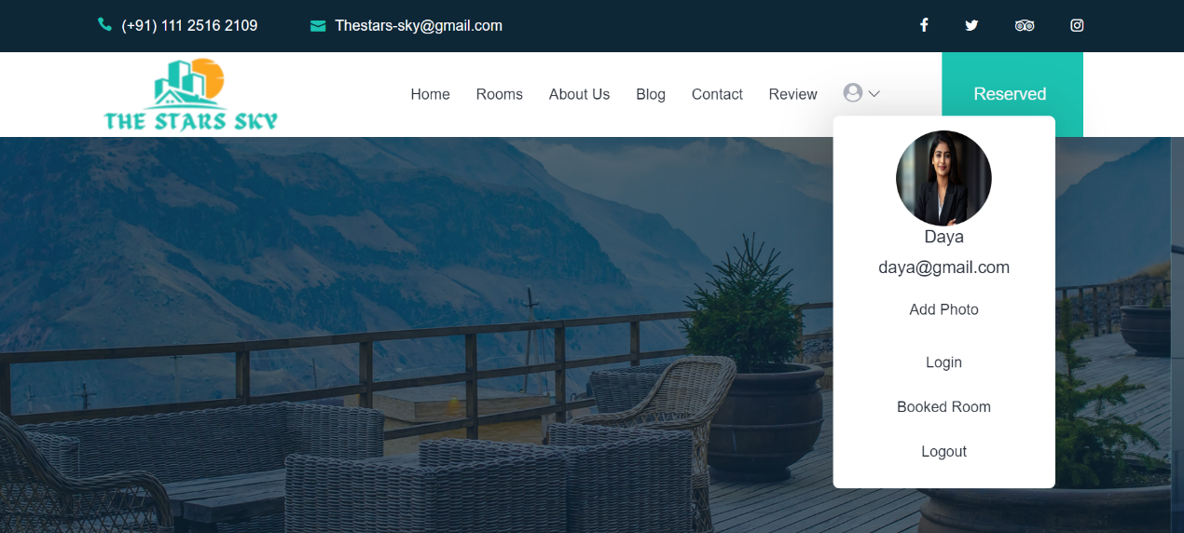

**DESCRIPTION:-** When Users visits the site after login, this page will appear with a user name and email.

**3.REGISTRATION PAGE:**

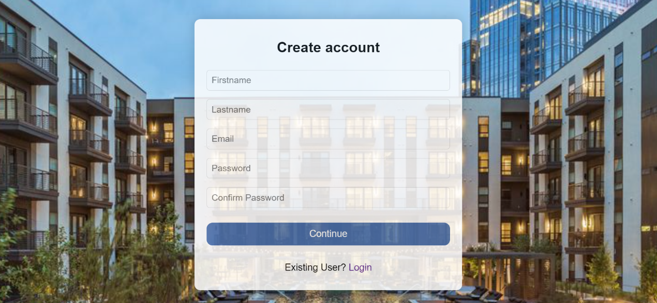

**DESCRIPTION:-** Users who visit our site for the first time, need to register themselves. And to register, they need to fill the details asked in the page displayed.

**4.LOGIN PAGE:**

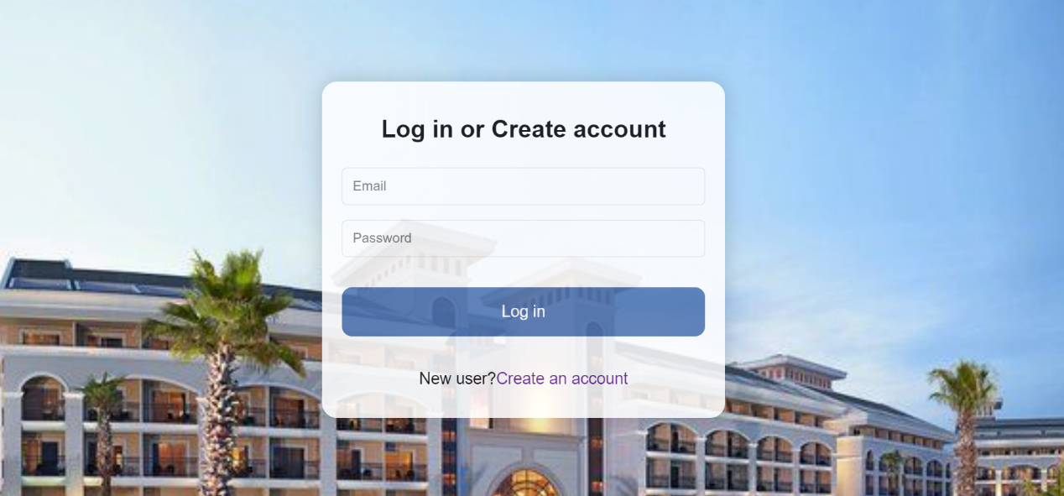

**DESCRIPTION: -** Admin and users can login through this single form.

**5.CHECK AVALIBILITY PAGE:**

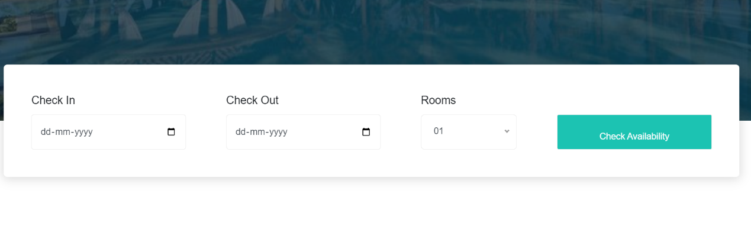

**DESCRIPTION:-** Users can checks available room in this page.

**6.TESTIMONIALS PAGE:**



**DESCRIPTION:-** Our user’s reviews are been shown in this page.

**7. ABOUT US:**

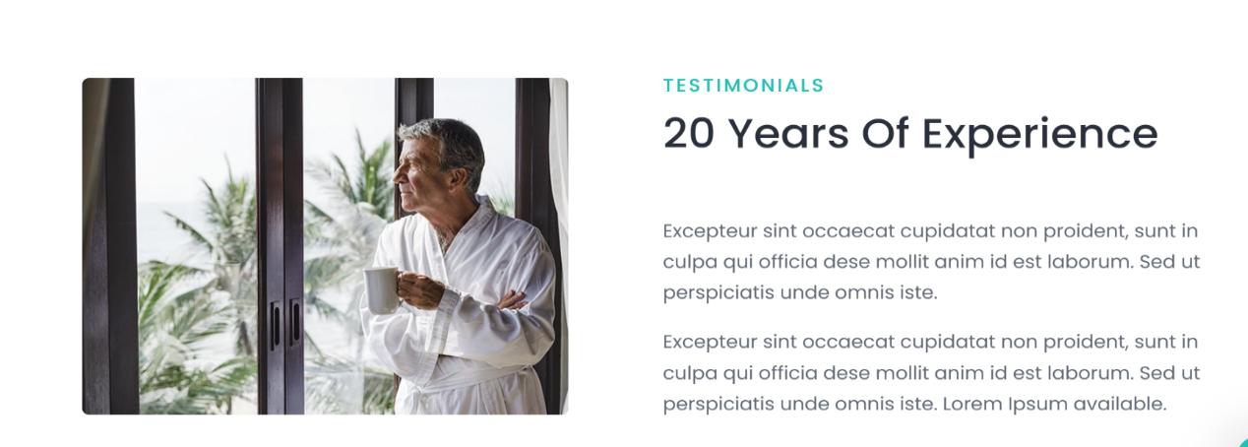



**DESCRIPTION: -** Through this page Users can get details and information of our Hotel easily.

**8.SERVICES PAGE:**

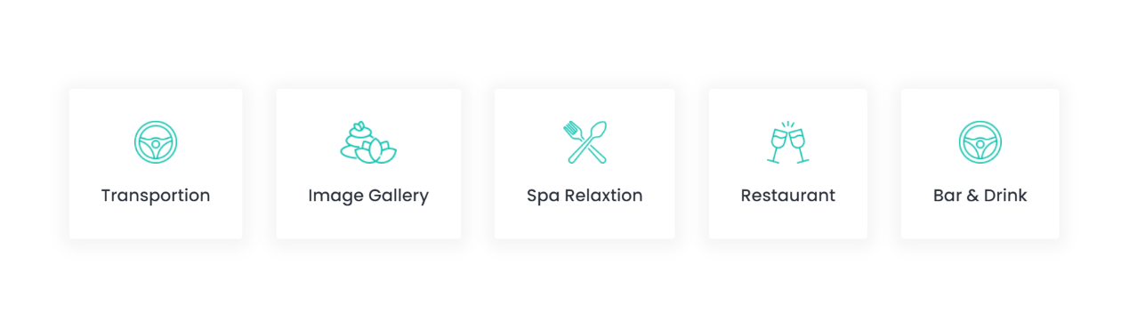

**DESCRIPTION: -** Through this page Users can get our services information.

**9. ROOMS PAGE:**

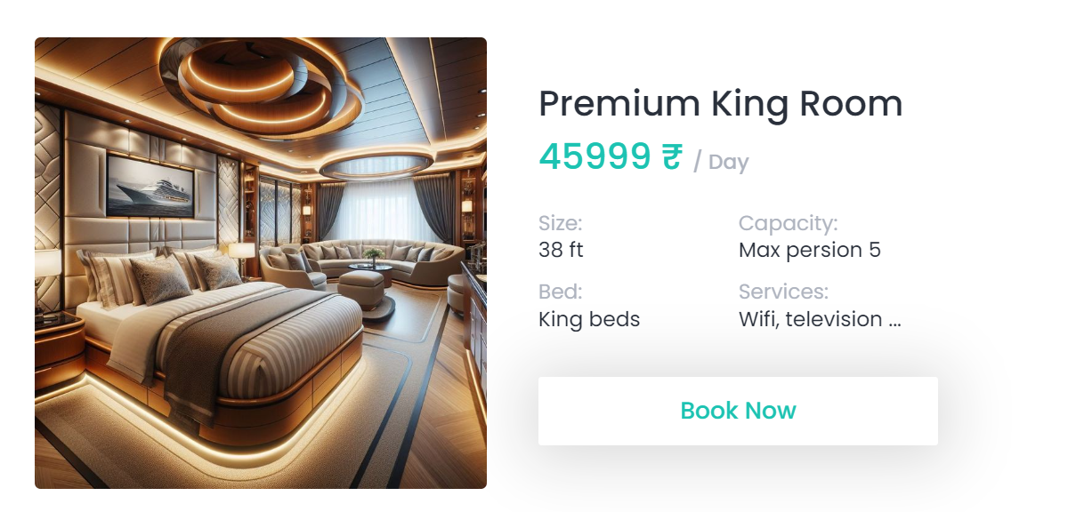

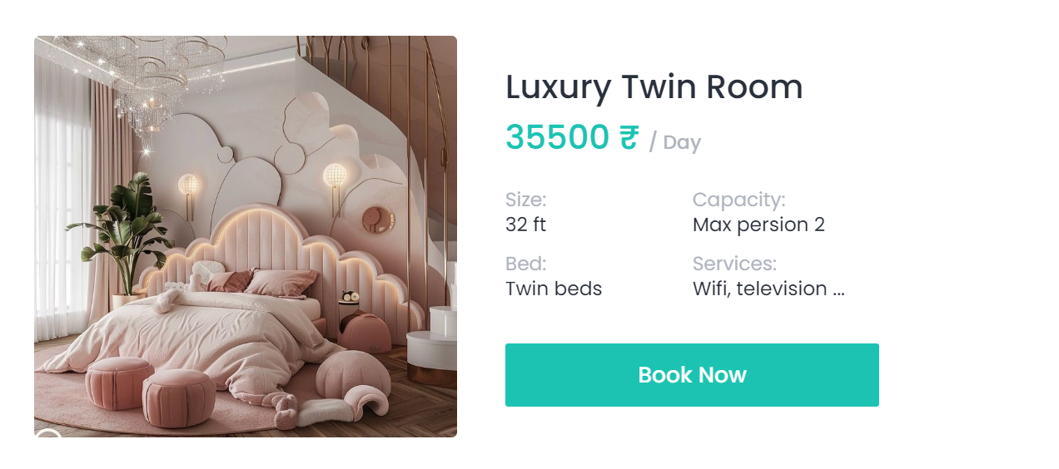

**DESCRIPTION:** All Users logged in as well as not logged in can view our rooms through this page and unless the user doesn’t login, they cannot add room to cart.

**10.CONTACT US PAGE:**

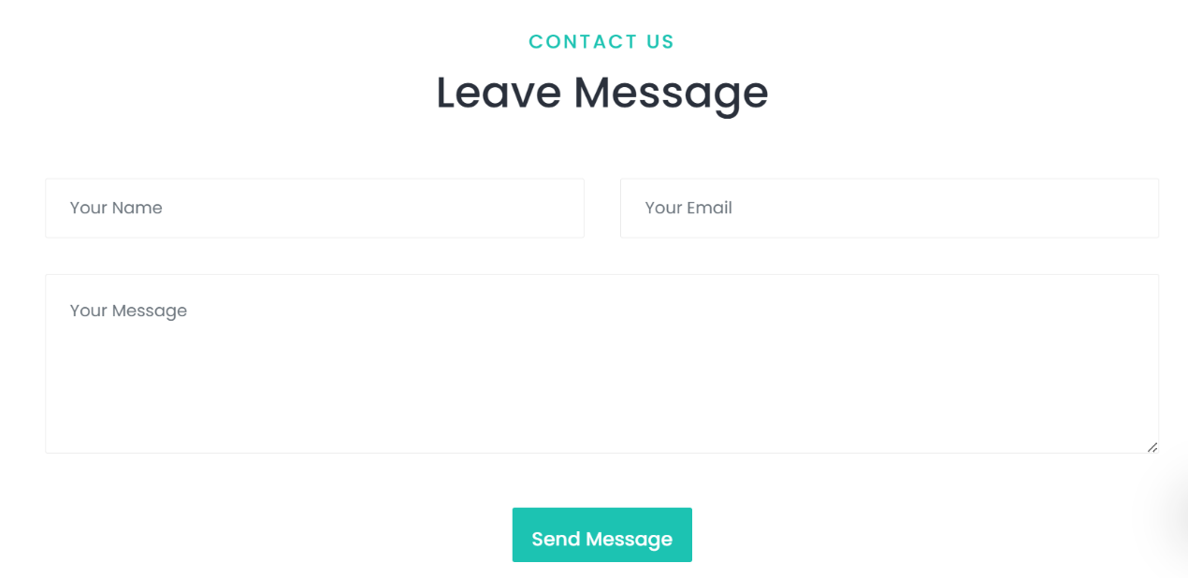

**DESCRIPTION: -** Any customer having query about the site can contact admin through this page by submitting their query.

**11.REVIEW PAGE:**

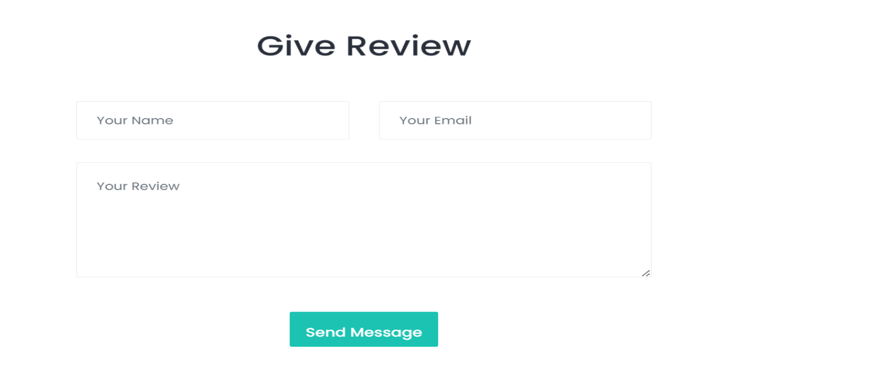

**DESCRIPTION: -** Review can be sent by customer through this page.

**12. VIEW SELECTION:**

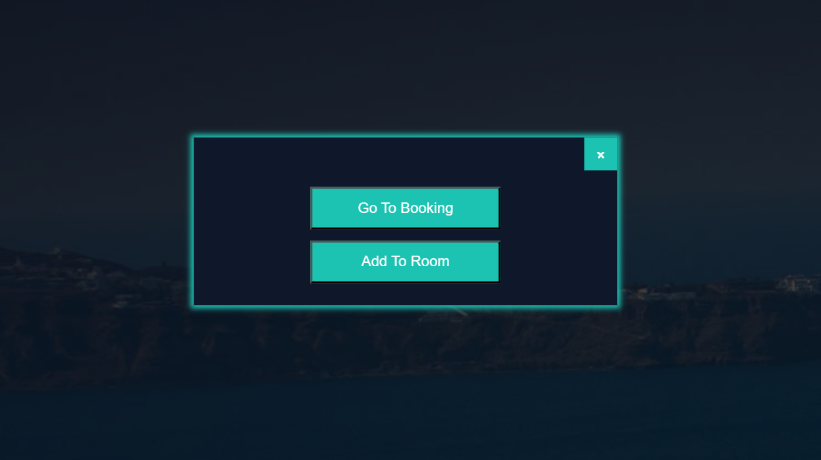

**DESCRIPTION: -**Users are allowed to select which page they want to see after adding room to cart i.e. they can view cart or room as per their need.

**13. CART:**

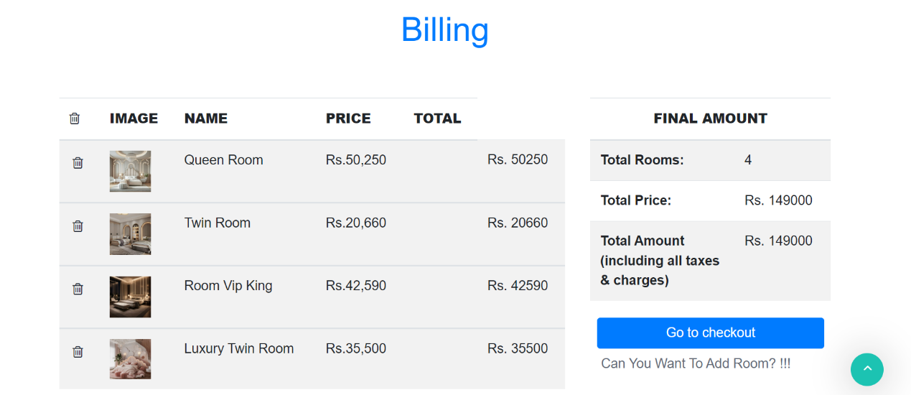

**DESCRIPTION: -** Users can view the rooms that they added to cart and can add or remove the rooms through this page.

**14. BOOKING :**

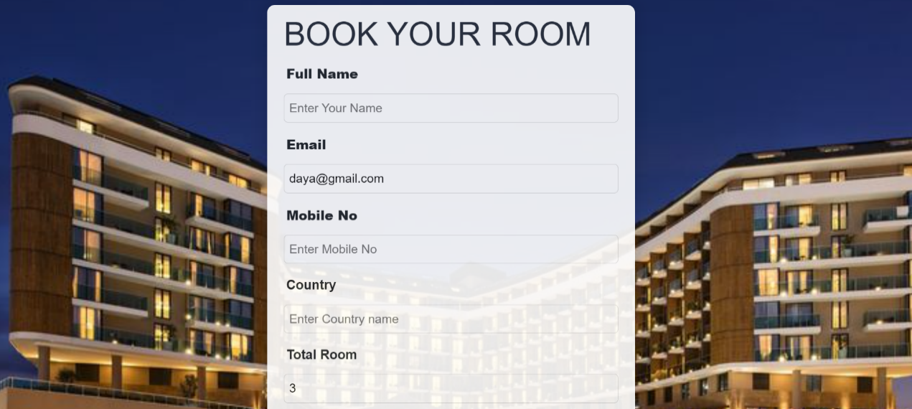

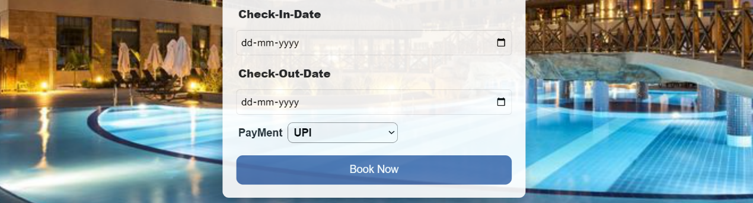

**DESCRIPTION: -** To complete the process of booked room the user has to fill out the details asked in this page and can confirm their Booking.

**15.RESERVE NOW:**

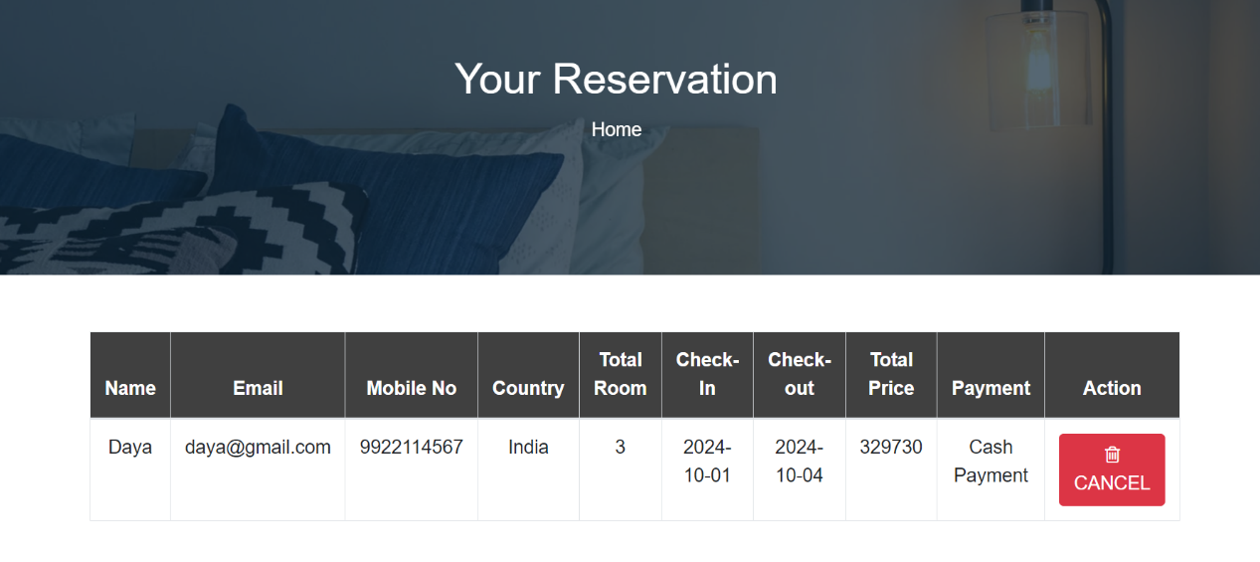

**DESCRIPTION:-** User can view as well as cancel their reservation through this page.

**Admin Side**

**1.ADMIN HOME PAGE:**

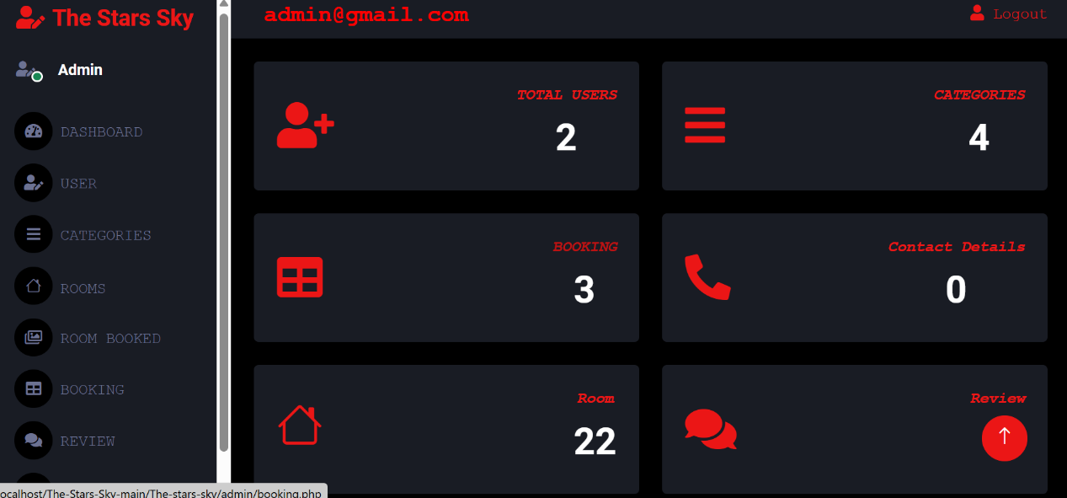

**DESCRIPTION: -** After admin gets loged in this page is viewed.

**2.USERS:**

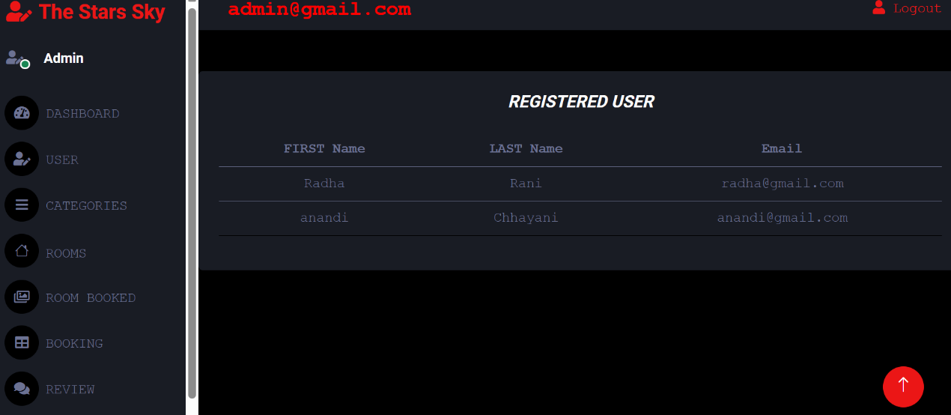

**DESCRIPTION: -** Admin can view all the registered users here.

**3.RESERVATIONS:**

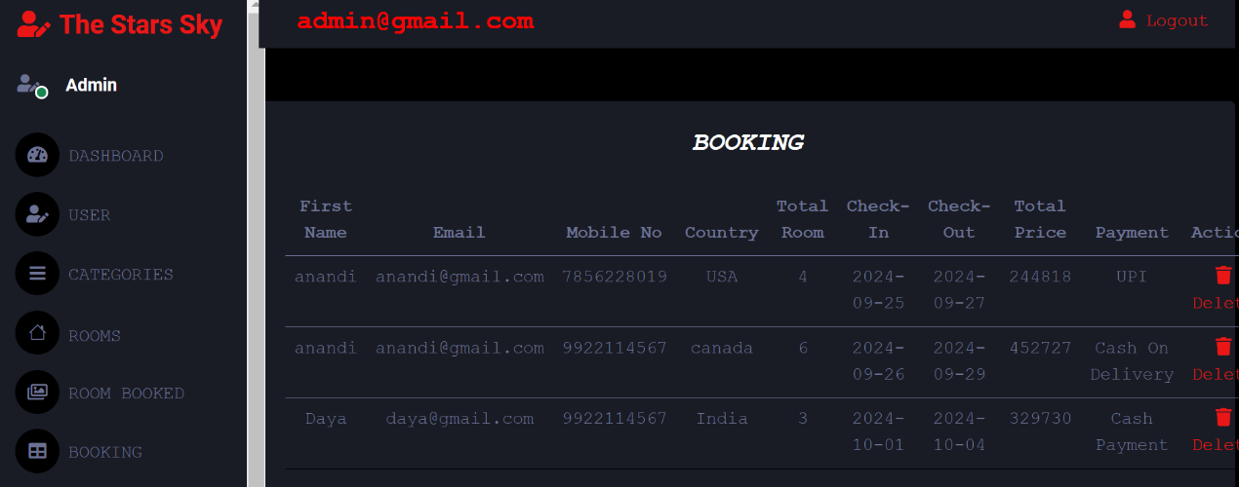

**DESCRIPTION: -** All the reservations are displayed to admin through this page.

**4.REVIEWS:**

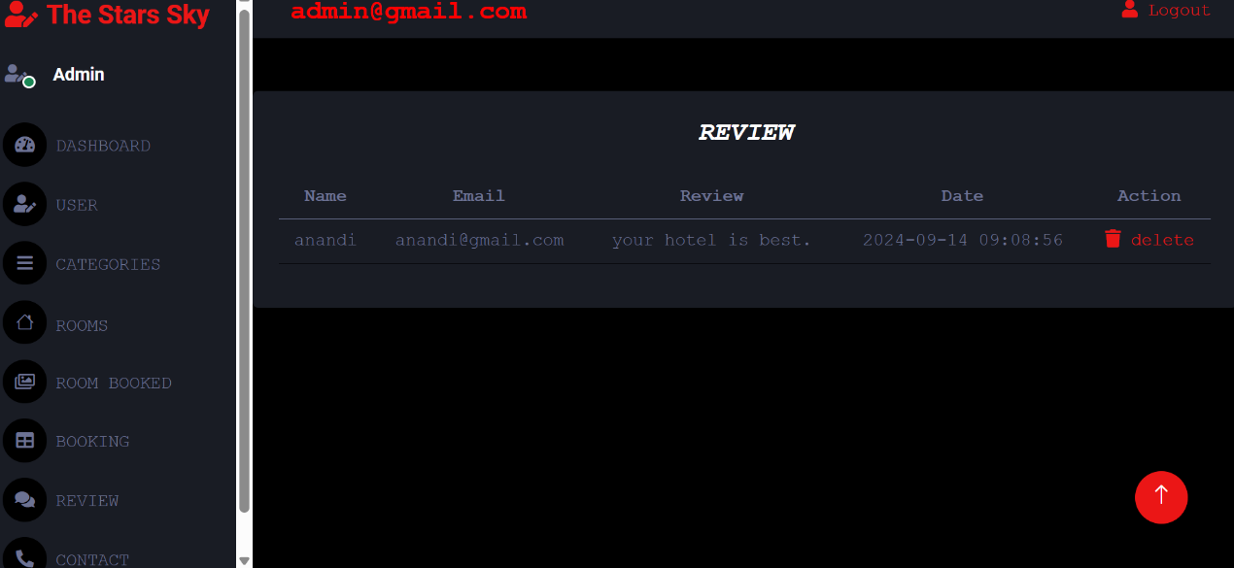

**DESCRIPTION:** - Admin can view all the Reviews through this page.

**5.Contact Details:**

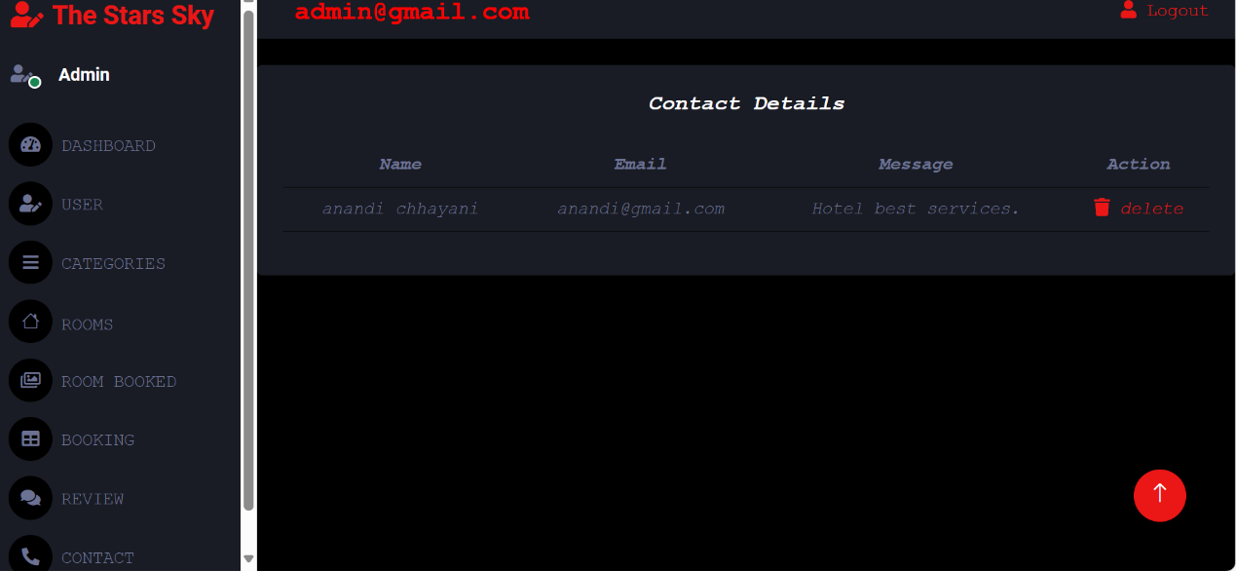

**DESCRIPTION: -** All the queries submitted is displayed to admin through this page.

**6.CATEGORIES:**

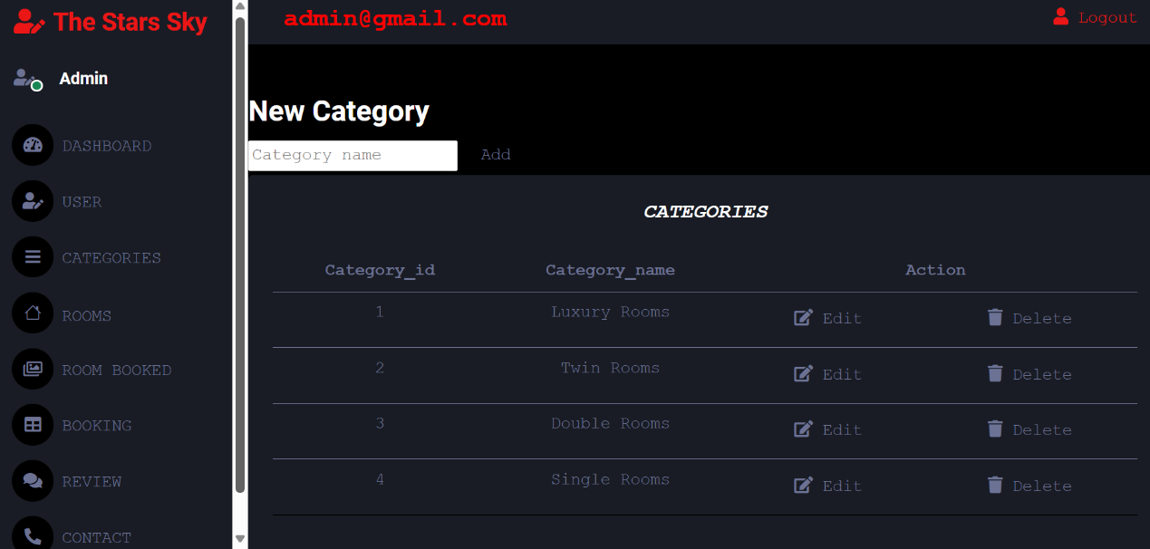

**DESCRIPTION: -** Admin can view, add or remove categories through this page.

**7.UPDATE CATEGORIES:**

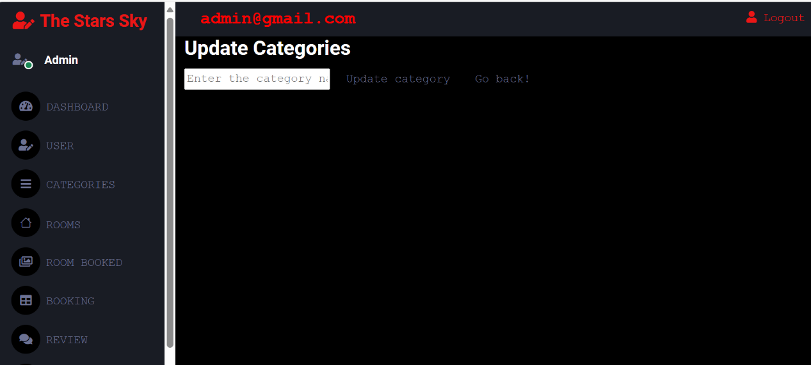

**DESCRIPTION:** - Admin can also update categories through this page.

**8.ROOMS:**

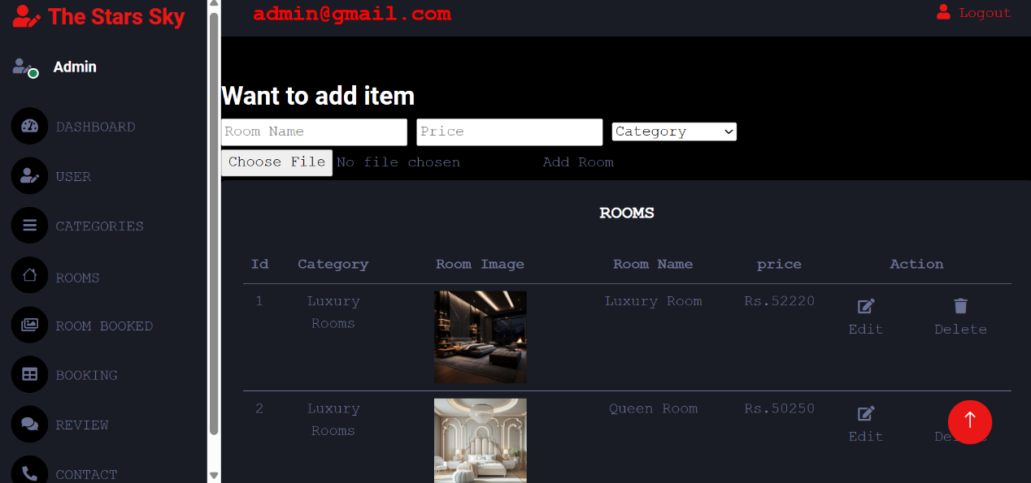

**DESCRIPTION: -** Admin can view, add or delete room through this page.

**9.** **UPDATE ROOM:**

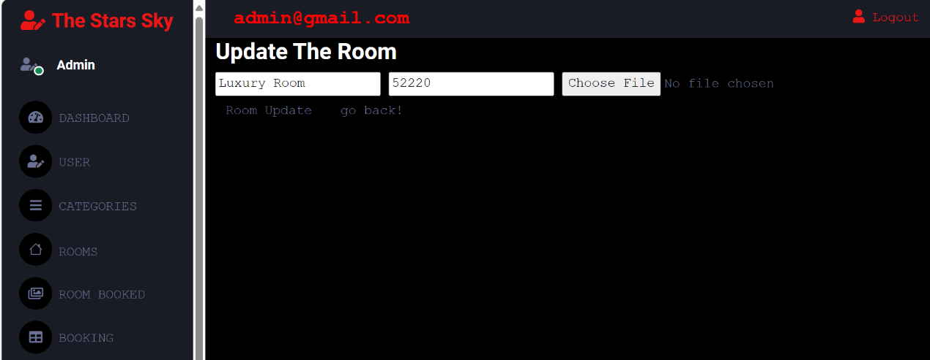

**DESCRIPTION:** - Admin can update room through this page.

**TEST CASE**

|  |  |  |  |  |
| --- | --- | --- | --- | --- |
| **TEST CASE ID** | **TEST CASE NAME** | **TEST CASE DESCRIPTION** | **VALIDATION MESSAGE** | **YOUR OUTPUT** |
| Registration_1 | Name | Required Field Validation | Please fill out this field. | True |
| Registration _2 | Name | Regular Expression | Required pattern="[A-Za-z\s]+ . | True |
| Registration _3 | Email | Required Field Validation | Please fill out this field. | True |
| Registration _4 | Email | Regular Expression | Required pattern  [a-zA-Z0-9._%+-]+@[a-zA-Z0-9.-]+\.[a-zA-Z]{2,}$ | True |
| Registration _5 | Password | Required Field Validation | Please fill out this field. | True |
| Registration _6 | Password | Regular Expression | Maximum Length must be 10. | True |
| Registration _7 | Confirm Password | Required Field Validation | Please fill out this field | True |
| Registration _8 | Confirm Password | Compare Validation | Password doesn’t match. | True |
| Booking_1 | Name | Required Field  Validation | Please Fill out this fields. | True |
| Booking_2 | Name | Regular Expression | Required pattern [A-Za-z\s]+ . | True |
| Booking_3 | Date | Required Field Validation | Please fill out this field. | True |
| Booking_4 | Date | Regular Expression | Check-Out-Date  must be after  Check-In-Date. | True |
| Booking_5 | Mobile number | Required Field  Validation | Please fill out this field. | True |
| Booking_6 | Mobile number | Regular Expression | Number must Max length 10 digits. | True |
| Booking_7 | Country | Required Field Validation | Country name must be at least 2 characters long. | True |
| Contact_1 | Email | Required Pattern Validation | Required pattern  [a-zA-Z0-9._%+-]+@[a-zA-Z0-9.-]+\.[a-zA-Z]{2,}$ . | True |
| Contact_2 | Subject | Required  Field Validation | Please fill out this field. | True |
| Contact_3 | Message | Required Field Validation | Please fill out this field. | True |
| Review_1 | Name | Required Field Validation | Please fill out this field. | True |
| Review_2 | Email | Required Pattern Validation | Required pattern  [a-zA-Z0-9.%+-]+@[a-zA-Z0-9.-]+\.[a-zA-Z]{2,}$ . | True |
| Review_3 | Experience | Required Field Validation | Please fill out this field. | True |
| Check Availability_1 | Date | Required Field Validation | Check-Out-Date must be after Check-In-Date. | True |

## GANTT CHART

|  |  |  |  |  |  |  |  |  |  |  |  |  |  |
| --- | --- | --- | --- | --- | --- | --- | --- | --- | --- | --- | --- | --- | --- |
| No. | Gantt Chart | June | | | July | | August | | | | September | | |
| 27/6 | 2/7 | | 12/7 | 27/7 | 15/8 | 30/8 | 15/9 | 22/9 | 29/9 | | 5/10 |
| 1. | Requirement  Gathering |  |  | |  | |  | | | |  | | |
| 2. | Analysis |  |  |  |  | |  | | | |  | | |
|  | Designing |  | |  |  | |  | | | |  | | |
|  | Coding |  | | |  |  |  | | |  |  | | |
|  | Testing |  | | |  | |  | | |  |  | | |
|  | Implementation |  | | |  | |  | | | |  | |  |
|  | Report |  | | |  | |  | | | |  |  | |

## LIMITATIONS

* For now, we have not accepted all online payments methods.
* Our website the admin must manually free booked rooms, as the process is not automated.

## FUTURE SCOPE

* Make system more users friendly.
* We will accept all type online payment methods.
* In the future, we will allow our customers to avail of additional services, such as transportation, spa and relaxation, bar and drinks, and restaurant services, online through our website.

## BIBLIOGRAPHY

**BOOKS:**

* Web Developing Using PHP

**WEBSITES:**

* www.w3schools.com
* www.geeksforgeeks.org

**WORK EXPERIENCE**

Our project guide **Miss. Radhika Raghani** provided full support to us. She always helped us just like a companion and not just as professional guide; she also provides the information required by us at any time.

She personally worked hard for our project. Also, the other faculty members related to the computer department never refused to help us. Also, the institute has provided the immense help by leap and bounds.

We also learnt some designing techniques; so, we heartily thankful to all who helped us in gradually climbing the steps towards the completion of this project of Online Hotel Room Booking system. Thank you, all faculty members, giving us such a great opportunity.

Last but not the least the overall experience of developing this project is as good as studying an entire new subject to feeling up the knowledge treasure.